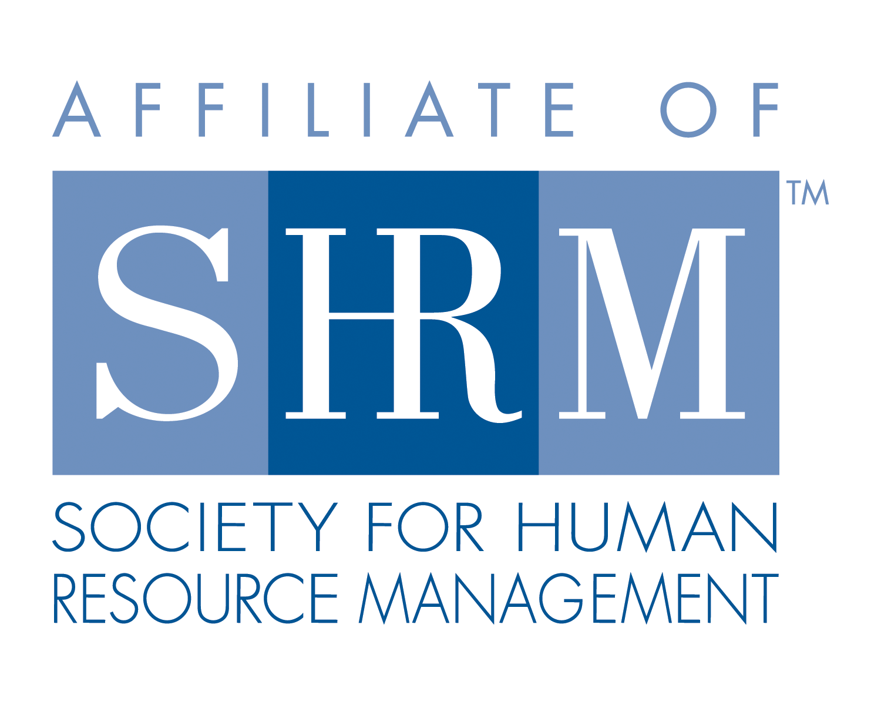
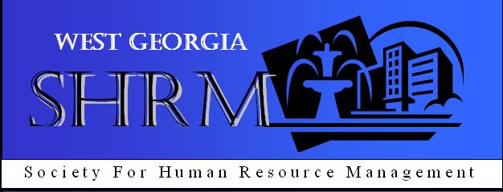

West Georgia SHRM Board Meeting
LaGrange College Cobb Board Room, LaGrange, GA
Tuesday, June 5, 2012

- Call to Order: 12:07 p.m. the SHRM Board meeting was called to order by Pamela Carrne.

Those present were: Pamela Carrne, Diana Goldwire, Krystle Miller, Michael Dollar, Frances Oubre, Kay Durand and Michael Davis.

- Minutes: approved as read

- Treasurer: The treasure’s report was emailed (6/1) by Karen Redic. We currently have $$10,100.36 in the account. All Approved.

- Chair Reports:

  - Membership: No new business.

  - Education/College Relations/Certifications: No new business.

  - SHRM Foundation: No new business.

  - Legislative: No new business.

  - Workforce: No new business.

  - Communications: No new business.

  - Diversity: This position on the board remains open.

  - At Large: No new business.

- Old Business:

- HRCI Certification Class: should we sponsor it again?

- New Business:

- Speakers – June: Melvin Hass – Constangy (EEOC); July: no meeting; August: Mark Butler – DOL Comissioner.
- We want to promote the August (8/9) meeting as a special event since Mark Butler will be speaking.
  - Get out flyers, make phone calls, emails invitations, etc.
  - Visitors/Non-Members will pay $15.00; news media may attend for free.
  - Have SHRM applications onsite.
  - Sign up for the event will end August 3rd.
  - A decision will be made on the location once we get a better count of how many people are attending.
- Membership drive to ramp up after August.

- The meeting was adjourned at 1:11 p.m.

Respectfully Submitted,
Krystle Miller
West Georgia SHRM, Secretary

